***HO CHI MINH UNBIVỘEGRSIIÁTOY ODFỤTCEVCÀHNĐOÀLOOGTYẠOAND EDUCATION***

***TRƯỜNG ĐẠI HỌC KINH BẮC***

License Plate Recognition

***Ho Chi Minh City, 1/2021***

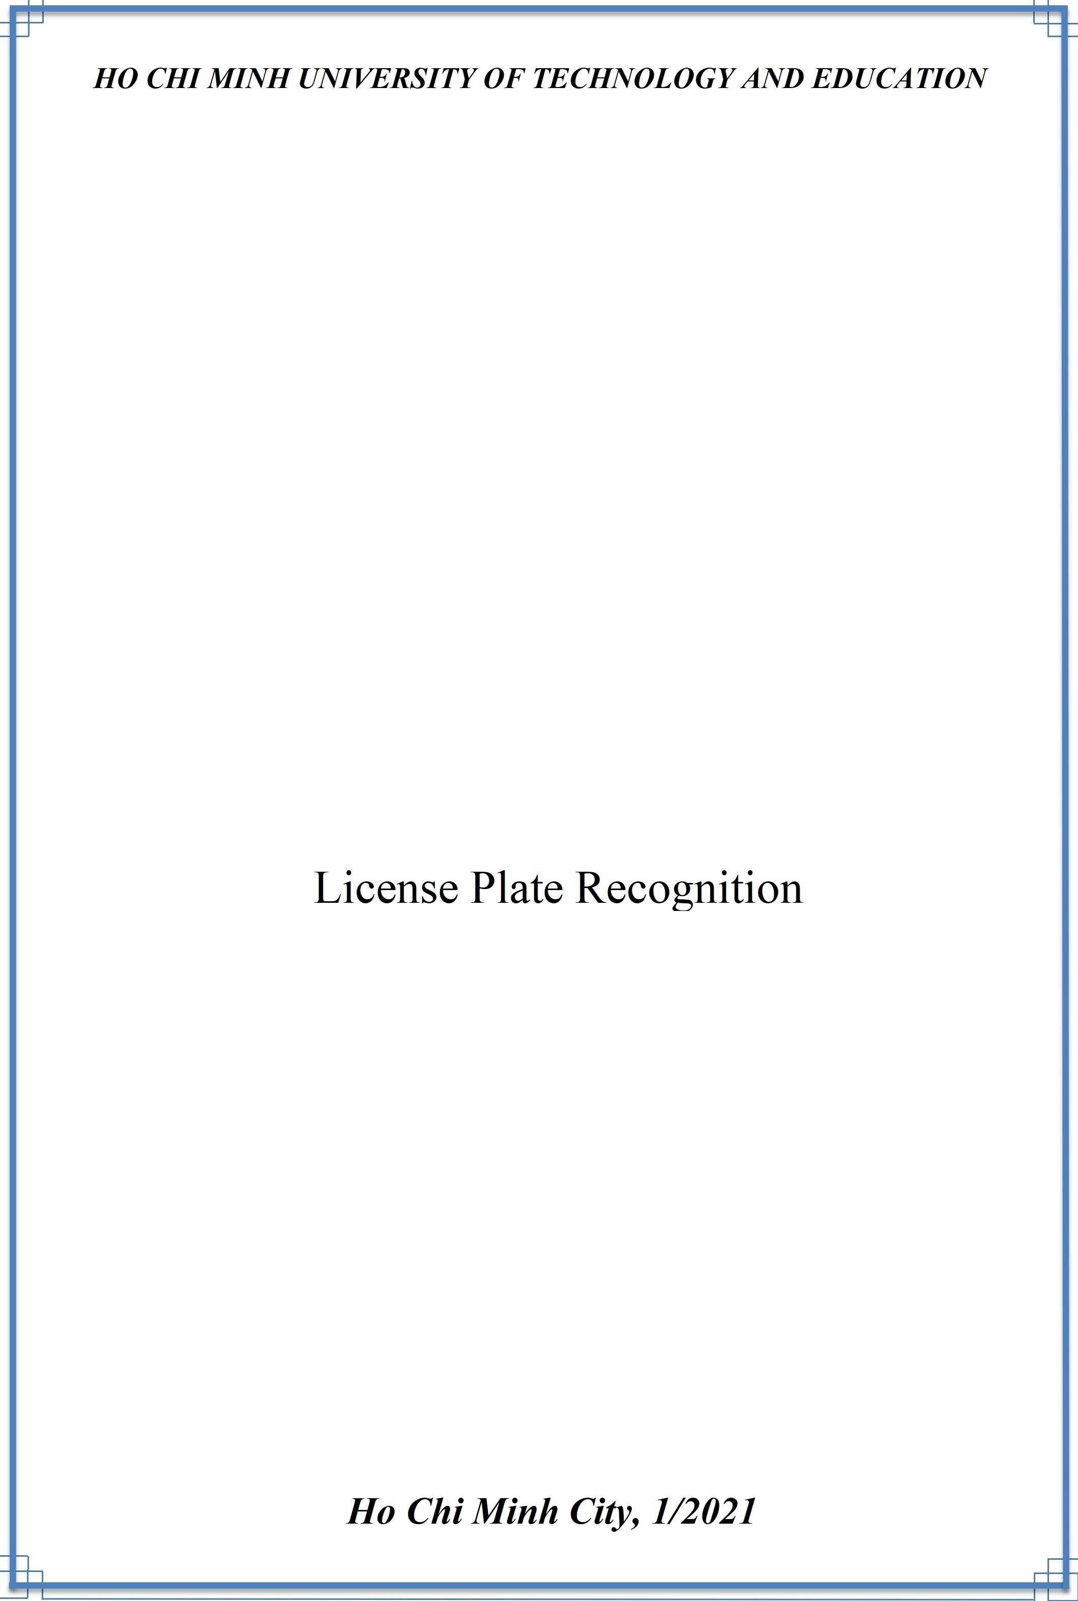

***FINAL PROJECT***

MACHINE LEARNING

|  |  |
| --- | --- |
| ***Lecturer: Nguyen Thien Bao*** |  |
| ***Members: Nguyen Van Dan*** | ***17110010*** |
| ***Truong Viet Hoang*** | ***17110033*** |
| ***Nguyen Dinh Khang*** | ***17110039*** |
| ***Phan Vinh Loc*** | ***17110049*** |
| ***Nguyen Tan Phat*** | ***17110059*** |
| ***Doan Viet Thuan*** | ***17110080*** |
|  |  |

***Score***

|  |  |  |  |
| --- | --- | --- | --- |
| **Criteria** | **Content** | **Presentation** | **Overall** |
| **Score** |  |  |  |

Observations of Instructor

.........................................................................................................

.........................................................................................................

.........................................................................................................

.........................................................................................................

Evaluation:

Nguyen Van Dan:...........................................................................

Doan Viet Thuan:...........................................................................

Nguyen Tan Phat:...........................................................................

Nguyen Dinh Khang:...........................................................................

Phan Vinh Loc:...........................................................................

Truong Viet Hoang:...........................................................................

Lecturer

## Nguyen Thien Bao

**Description**

The license plate identification system is a system capable of analyzing the image and identifying the number plate on the vehicle, through images. The following is to define information such as owner, etc.

**Algorithm**

4 main algorithms:

1. We have to change color of original image that makes this image easily to detect. This step uses **Color Space Conversions algorithm**.
2. We use **Image Filter and Canny edge detection** to get the shape of the object which you want to detect.
3. After that, getting the XY coordinate to know locate of the number plate. In this step, **contours** help we do that.
4. Final we just use **SVM** to detect and classify number on the plate and get the result.

**Work**

|  |  |  |
| --- | --- | --- |
| Name | ID | Content |
| Doan Viet Thuan | 17110080 | Develop and enhance code |
| Truong Viet Hoang | 17110033 | Search and collect algorithm, test code |
| Nguyen Van Dan | 17110010 | Develop and enhance code |
| Nguyen Tan Phat | 17110059 | Develop and enhance code |
| Nguyen Dinh Khang | 17110039 | Demo and compile code for results |
| Phan Vinh Loc | 17110049 | Search and collect algorithm, test code |